# Diseño de Prueba para Smart Watch en Figma.

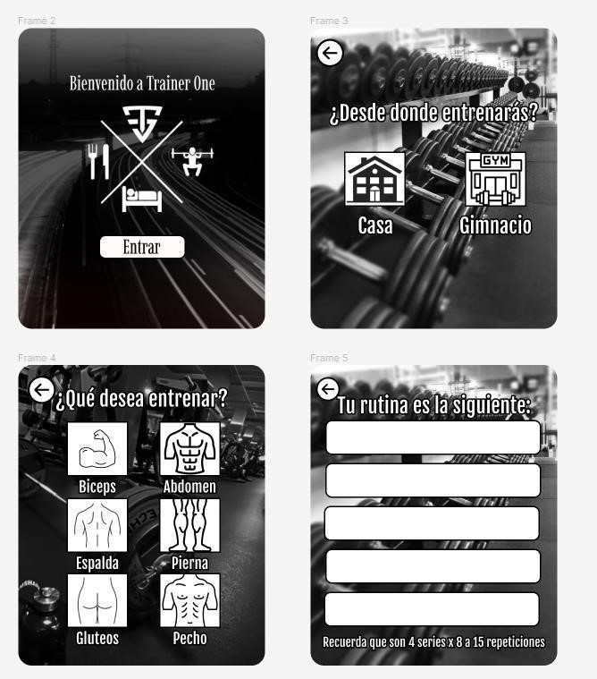



**Link:**

[**https://www.figma.com/proto/DVfMButZ0ZlcTFLFgEy9**](https://www.figma.com/proto/DVfMButZ0ZlcTFLFgEy963/Untitled?node-id=0%3A1)

[**63/Untitled?node-id=0%3A1**](https://www.figma.com/proto/DVfMButZ0ZlcTFLFgEy963/Untitled?node-id=0%3A1)